Borrower: Mr. Chea Pisey & Mdm. Chen Sopheary

1. Mr. Chea Pisey

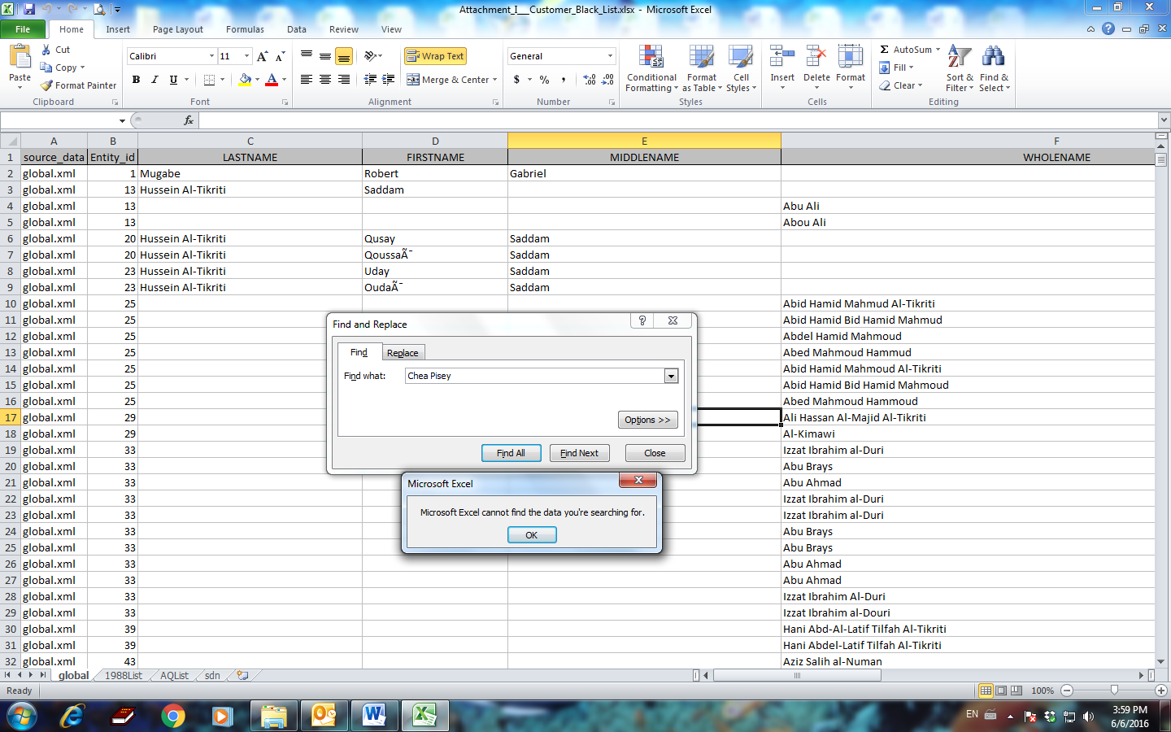

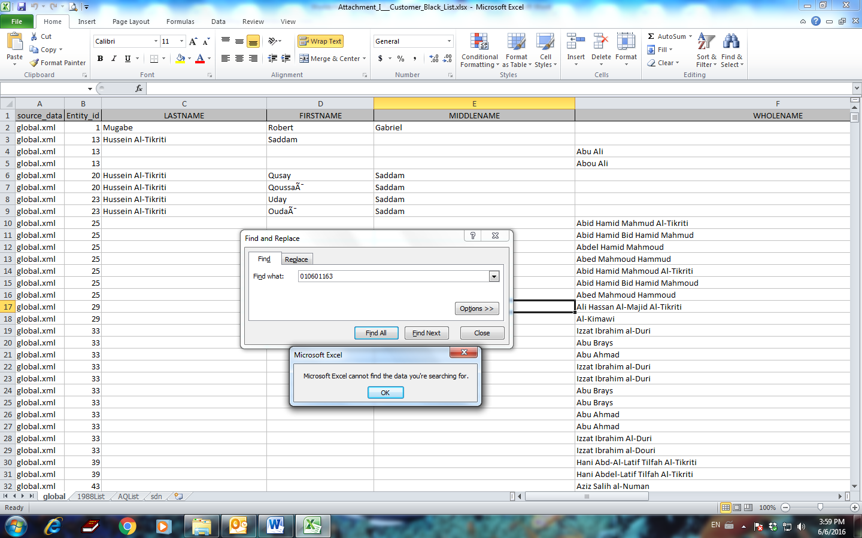

2. Mdm. Chen Sopheary

